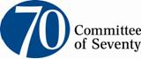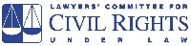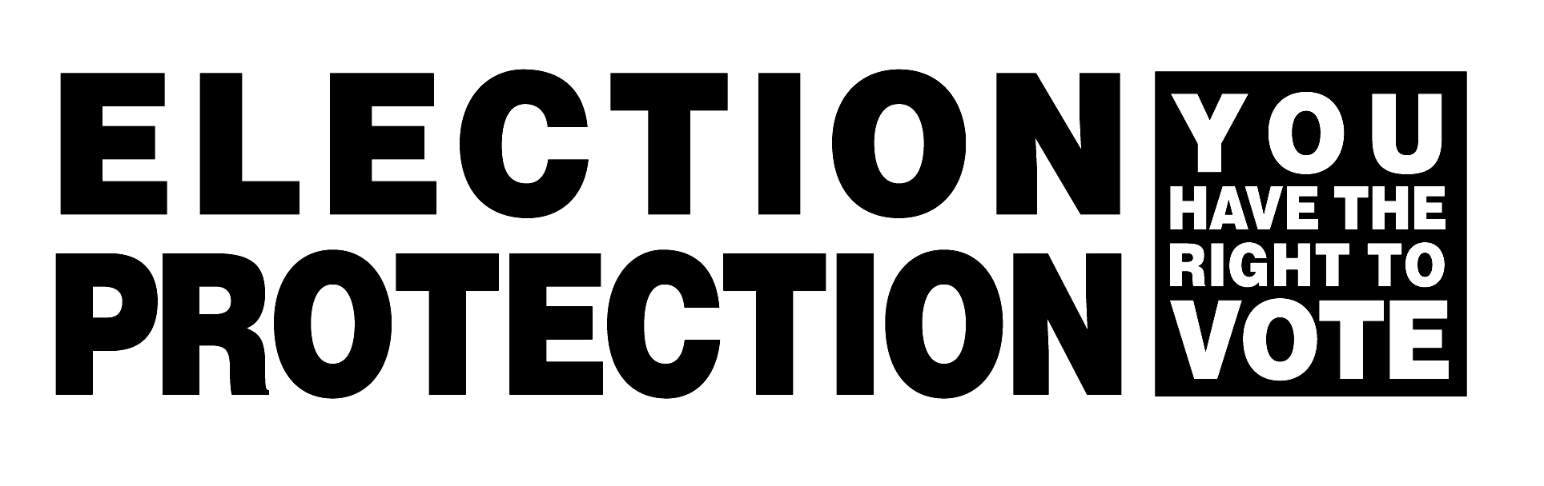
FOR IMMEDIATE RELEASE Contact: Stacie B. Miller
Director of Communications
Lawyers’ Committee for Civil Rights Under Law (202) 662-8600
(202) 445-6101 (cell)

Election Protection Coalition Fields Over 1,000 Calls
Reporting Scattered Problems Throughout Pennsylvania

PHILADELPHIA – April 22, 2008 (10:30 p.m. Update) – As polls closed across Pennsylvania this evening, the Election Protection Coalition reported receiving over 1,000 calls to the Voter Protection Hotline throughout the day. The Coalition entered more reports into its election reporting database than in any previous state primary, including primaries earlier this year in California, New York and other populous states.

Nationally renowned Lawyers’ Committee for Civil Rights Under Law together with an extensive coalition of partners throughout Pennsylvania, including Philadelphia-based Committee of Seventy, responded to voting problems throughout the state through a comprehensive voter protection program. Nearly 1,000 nonpartisan citizen and legal volunteers monitored polling places throughout Pennsylvania. Approximately 800 volunteers worked in Philadelphia. Voters reported issues by way of the coalition hotline (1-866-OUR-VOTE) and through hundreds of field volunteers throughout the state.

“Our coalition worked since the polls opened this morning to ensure the integrity of the vote in Pennsylvania, and to be sure the process is conducted fairly,” said John E. McKeever, Esquire, a partner at law firm DLA Piper, who serves on the Boards of Directors of both the Lawyers’ Committee and the Committee of Seventy. “Pooling our respective resources and strengths for this crucial primary helped to ensure that all eligible citizens have an equal opportunity to exercise the most fundamental of all rights – the right to vote.”

Jonah Goldman, director of the National Campaign for Fair Elections of the Lawyers’ Committee’s Voting Rights Project said, “In this historic primary season, voters across the country have turned out in droves to exercise their fundamental right to vote. Today Pennsylvanians followed suit. Unfortunately, the heartening story of record turnout is tempered by the real problems voters face as they try to cast a ballot. Poorly trained poll workers, problems with voting machines and inaccurate voter registration rolls caused countless eligible voters to be needlessly refused the right to vote.”

The high turnout exposed many of the fundamental problems that plague the election administration system throughout the state, together with allegations of voter intimidation and disenfranchisement merit further investigation. One of the most troubling issues today was a barrage of reports from voters who have been registered as Democrats for years, but were listed as unaffiliated and so had to vote provisionally. When this problem surfaced earlier in the day, the Coalition took action by alerting the county Boards of Election to the issue and releasing a statement to the media advising voters who encounter this problem to vote provisionally. It is unclear at this time how widespread this problem was.

The most frequently reported problems throughout the day included general polling place issues such as poll workers giving incorrect information, rule violations and poor administration regarding polling locations (250+ calls); registration issues (200); equipment malfunction at the polls (150) and voter intimidation (80+). Some sample reports include:
- At one location, the head poll worker asked for a voter’s registration card, and yelled out to everyone else the voter’s name, that the voter was a Democrat, the voter’s address and that the machine was not set up for a Democrat. The voter felt very disrespected and that this was an invasion of her privacy; she does not want to go back to vote again because of this worker’s behavior.
- One man was told that he could not vote at his polling place because he was a Republican.
- In Delaware County, one voter reported that the voting machines at her precinct were set for Republicans only. She told the poll worker that she was a Democrat and the worker replied, “Not today.” The voter was not able to cast a vote, but The League of Women Voters provided her with the phone number of the Delaware County Board of Elections to report and resolve the issue.
- A voter reported that, at one location, building materials were being thrown off the roof of the polling place to prevent voters from entering.
- One caller reported a polling location with only three voting machines and no printers working. Voters were leaving without being offered emergency ballots.
- A voter took her child with her to vote, but the poll worker wouldn’t let the child into the voting area with her. When the child’s mother asked why, the poll worker claimed that it was because her child “can read.”

According to the Commonwealth’s Department of State, there are 8,320,083 registered voters in Pennsylvania. In Philadelphia, which has just over one million voters, the City Commissioners’ Office reports that nearly 114,000 individuals registered to vote between October 27, 2007 and March 24, 2008, the last date to register before the primary. The rise in the City’s voter registrations is attributed to the intensity of the national Democratic primary and several local contests. Seventy has already announced plans for unprecedented oversight of high-profile and contentious primary races within the City’s First Senatorial District and the 179th and 184th House Districts.

The Election Protection coalition is the nation’s largest nonpartisan voter protection. Pennsylvania partners include The Lawyer’s Committee for Civil Rights Under Law; the Committee of Seventy; Common Cause; People for the American Way Foundation; Avencia; Congresso de Latino Unidos; Dechert LLP; DLA Piper; Drexel University; Greater Philadelphia Cares; KPMG International; League of Women Voters of Philadelphia; Morgan, Lewis & Bocklus; Philadelphia AFL-CIO; Special People in N.E.; Temple University; University of Pennsylvania Law School; The Daily News and White & Williams LLP.

The Lawyers’ Committee for Civil Rights Under Law (LCCRUL), a nonpartisan, nonprofit organization, was formed in 1963 at the request of President John F. Kennedy to involve the private bar in providing legal services to address racial discrimination. The principal mission of the Lawyers' Committee is to secure, through the rule of law, equal justice under law, particularly in the areas of housing, community development, employment, voting, education and environmental justice. For more information about the LCCRUL, visit www.lawyerscommittee.org.

# # #

